Massey Days Reunion June 7 8 & 9 2018 W6368 E Pine St (off Hwy 44) Dalton Wi 53926 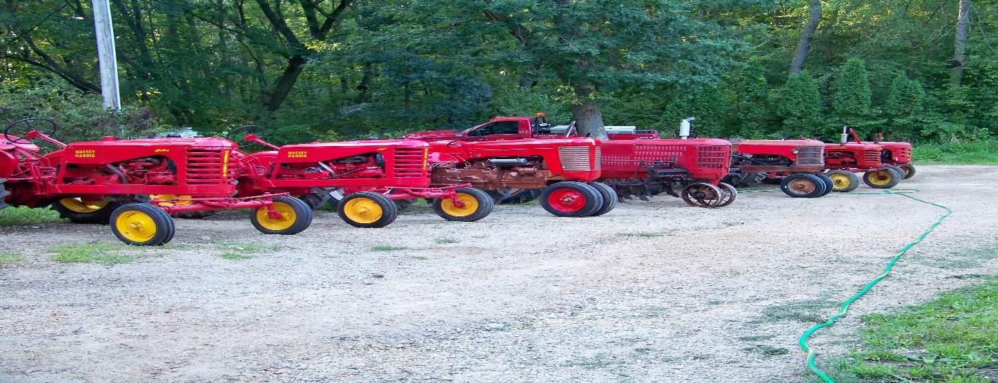 Hosted by Dennis & Suzie Roundy slroundy@yahoo.com 920-382-5997 Fred & Kay Heidt 920-348-5476 Food served daily. Saturday night banquet RSVP if attending the banquet Limited indoor space for vendors- let us know Other activities in town- Moto-Static car show in the park Vintage shops to be open on Main St (Cty Hwy FF) Hotels in Portage about 25 miles away Best Western 608-742-2200 Super 8 608-742-8330 RidgeMotorInn 608-742-5306 Local campgrounds Within 15 miles Glacier Valley 920-348-5488 Grand Valley 920-394-3643 Bring something to display or just visit with friends

